import numpy as np

import pandas as pd

from sklearn.model_selection import train_test_split

from sklearn.linear_model import LogisticRegression

from sklearn.metrics import accuracy_score

# loading the dataset to a Pandas DataFrame

credit_card_data = pd.read_csv('/content/credit_data.csv')

# first 5 rows of the dataset

credit_card_data.head()

credit_card_data.tail()

# checking the number of missing values in each column

credit_card_data.isnull().sum()

# distribution of legit transactions & fraudulent transactions

credit_card_data['Class'].value_counts()

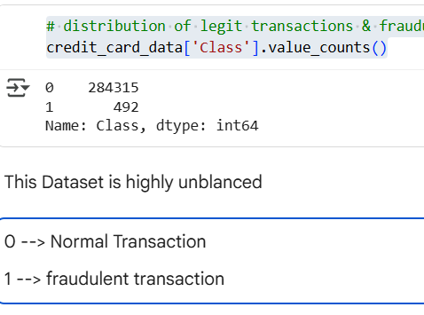

# separating the data for analysis

legit = credit_card_data[credit_card_data.Class == 0]

fraud = credit_card_data[credit_card_data.Class == 1]

print(legit.shape)

print(fraud.shape)



# statistical measures of the data

legit.Amount.describe()

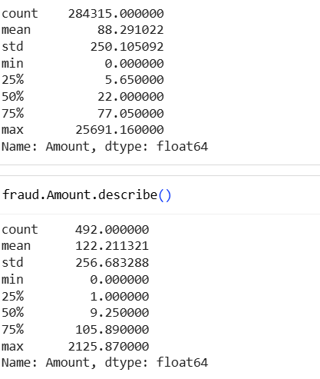

# compare the values for both transactions

credit_card_data.groupby('Class').mean()

Under-Sampling

Build a sample dataset containing similar distribution of normal transactions and Fraudulent Transactions

Number of Fraudulent Transactions --> 492

new_dataset = pd.concat([legit_sample, fraud], axis=0)

new_dataset.head()

new_dataset.tail()

new_dataset['Class'].value_counts()

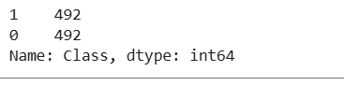

new_dataset.groupby('Class').mean()

X = new_dataset.drop(columns='Class', axis=1)

Y = new_dataset['Class']

print(X)

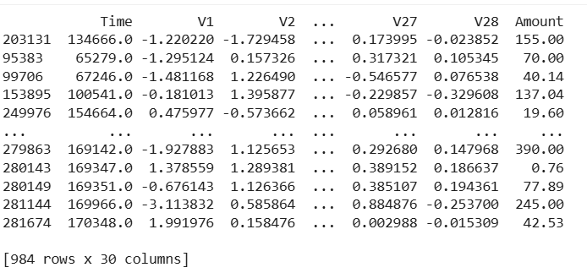

print(Y)

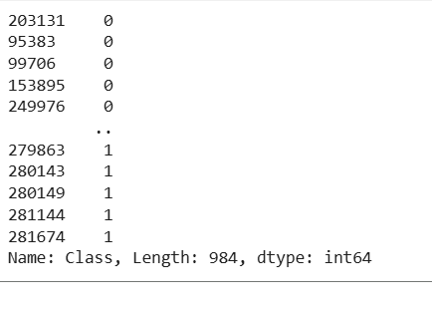

X_train, X_test, Y_train, Y_test = train_test_split(X, Y, test_size=0.2, stratify=Y, random_state=2)

print(X.shape, X_train.shape, X_test.shape)

(984, 30) (787, 30) (197, 30)

model = LogisticRegression()

# training the Logistic Regression Model with Training Data

model.fit(X_train, Y_train)

LogisticRegression(C=1.0, class_weight=None, dual=False, fit_intercept=True,

intercept_scaling=1, l1_ratio=None, max_iter=100,

multi_class='auto', n_jobs=None, penalty='l2',

random_state=None, solver='lbfgs', tol=0.0001, verbose=0,

warm_start=False)

##

Model Evaluation

Accuracy Score # accuracy on training data

X_train_prediction = model.predict(X_train)

training_data_accuracy = accuracy_score(X_train_prediction, Y_train)

print('Accuracy on Training data : ', training_data_accuracy)



# accuracy on test data

X_test_prediction = model.predict(X_test)

test_data_accuracy = accuracy_score(X_test_prediction, Y_test)

print('Accuracy score on Test Data : ', test_data_accuracy)

Accuracy score on Test Data : 0.9390862944162437